**David Cesiel, Hobey Kuhn, Kat Liu, and Ansgar Strother**

**Eecs498-003: Winter 2013**

**Bot Lab**

**Due: Monday March 18**

**Task #1:**

*Q1.1. The following snippet of code is our lcm type for robot positioning:

struct pos_t

{

boolean finished;

int64_t timestamp;

float delta_x;

double theta;

}

Our group chose to represent coordinate points as floats (see delta_x). Our group chose to represent the angle as a double (see theta). Although floats have less precision than a double, they require less space. Coordinate points don't need the high level precision that we need with the angle, especially since gyros in our robot have a high error (2-5 degrees/minute). Thus, in order to maximize our accuracy and space complexity, we chose to use a double for our angle theta and floats for our coordinate points. As opposed to sending the coordinate points, we send delta_x, which is then used with theta and our history of coordinate frame transformations to calculate position.

Our bot only publishes the POSE message when delta_x does not equal zero. This keeps us from spamming the network, and it also keeps us from doing any unnecessary calculations in odometry when the bot is not moving.

*Q1.2.

*Q1.3.

*Q1.4. Below is a screenshot of our GUI. The main frame shows the bot traveling through space, as well as the status of the bot (executing or idle). The secondary frame plots the error ellipse, and displays information about the ellipse.

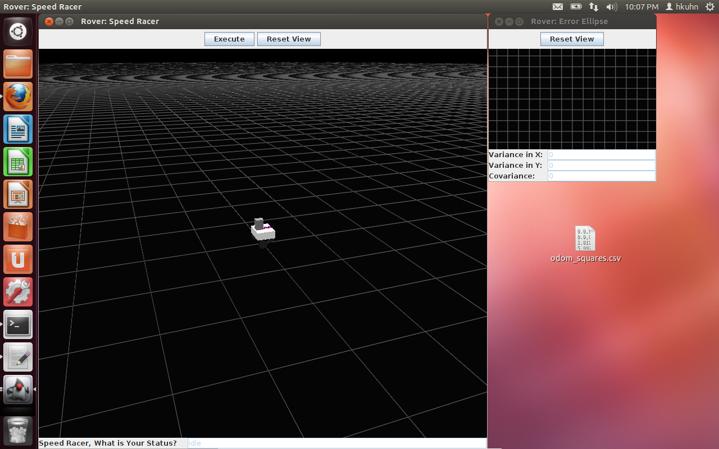

*Q1.5.

**Task #2:**

Q2.1. Below are a few of our training examples for testing our blue line detection algorithm. This algorithm takes unrectified images. In order to evaluate our algorithm’s performance, we encoded ground truth data for each image: initial points, final points, and slope of each blue line in pixel coordinates. In other words, the blue line detection algorithm returns line segments. In order to calculate the error rate, we compare the ground truth data to our algorithm’s data, with more weight assigned to the slope, and some weight assigned to the points. Refer to Q2.2 to see a breakdown of five training examples and our algorithm’s success rate for each test. The score is calculated as follows: 0.8*(1 – error in slope) + 0.05*(1 – error in initial point x) + 0.05*(1 – error in initial point y) + 0.05*(1 – error in final point x) + 0.05 *(1 – error in final point y).

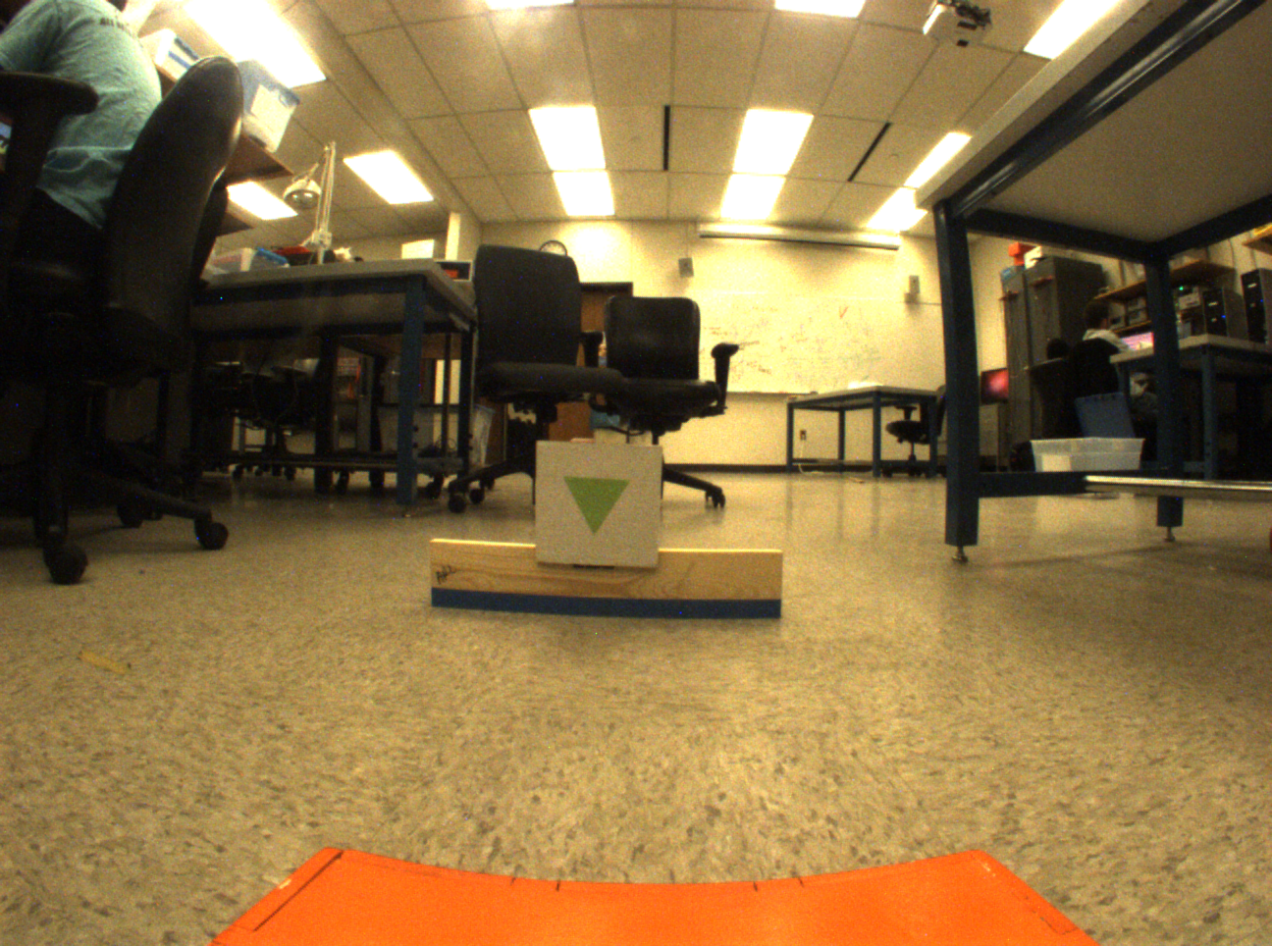 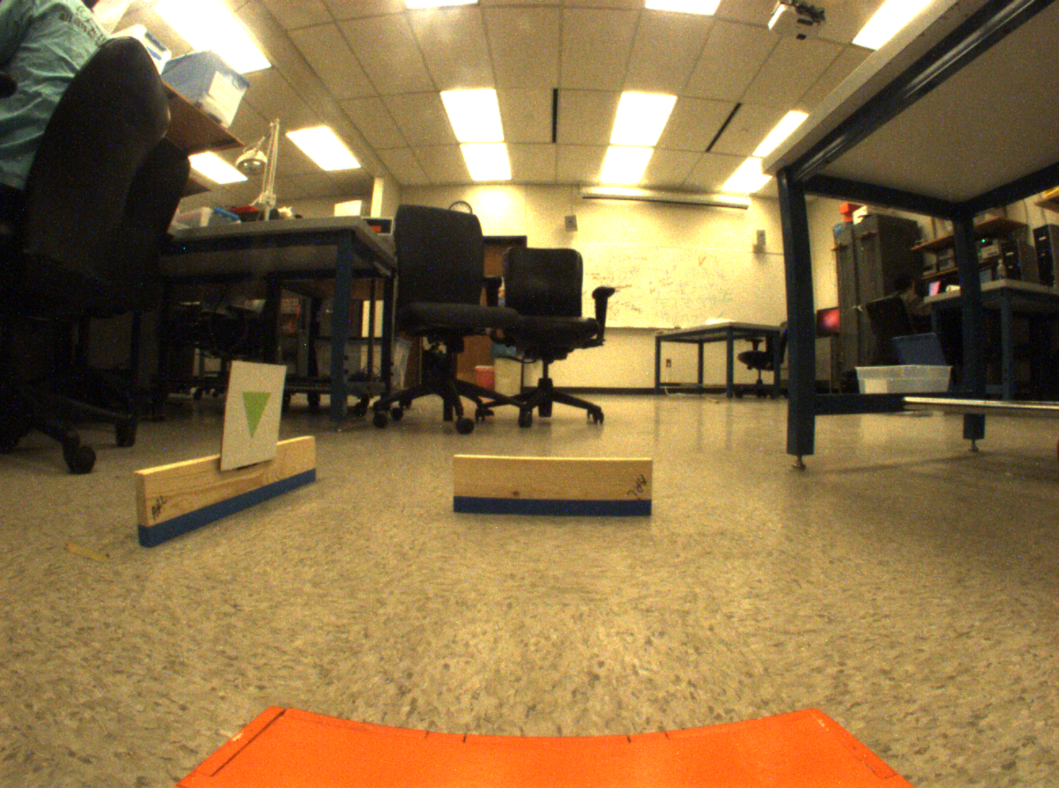

Q2.2. The initial idea for our blue line detection algorithm started with simple canny edge detection of a convolved, binarized image. This choice was extremely accurate in finding lines (very little noise), but the time it took far exceeded the benefit of its accuracy. We then went for a more simple approach, gray scaling and binarizing the image to find where objects touched the ground. This worked very well, but it also detected a large amount of noise and other boundaries not necessarily denoted by blue tape, which posed an issue during line segmentation and fitting. The final approach involved thresholding the image with hues of blue, working from the bottom of the image up, to detect the first instance of a blue line.

The next portion of the blue line detection algorithm is the line segmentation algorithm. This portion takes in a map of points that correspond to blue pixels, and tries to fit lines. The original method was a general segmentation algorithm that tried to distinguish lines by looking at slope as it traversed the image from left to right. This proved to be very tricky because of the amount of noise involved with the camera, even when points were meant to be on the same line. Our final approach involved implementing RANSAC, which proved to be fast and accurate. The following screenshots depict parts of our process:

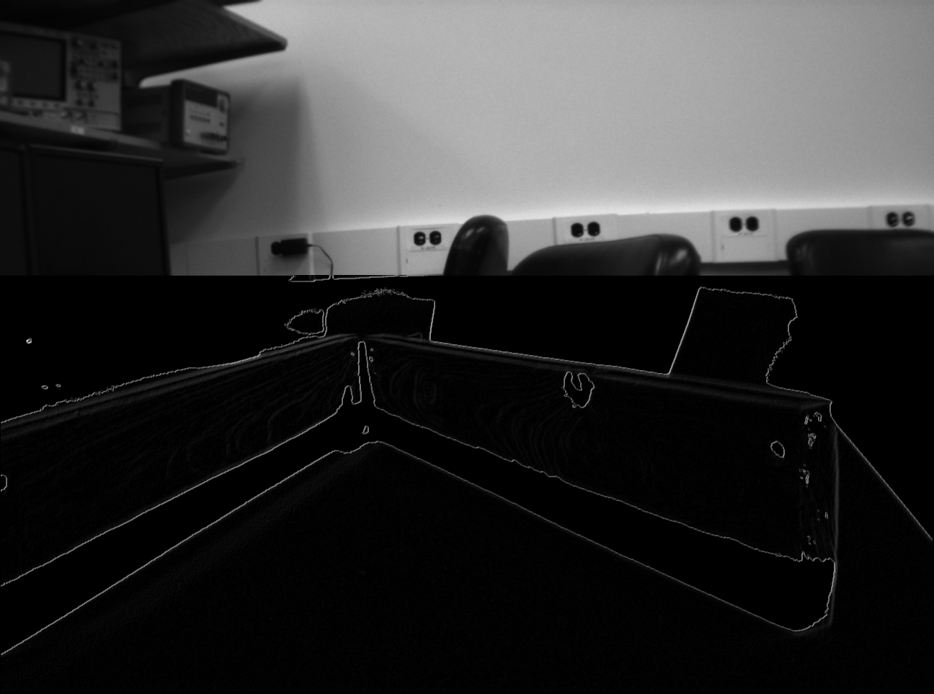

**Canny Edge Detection**

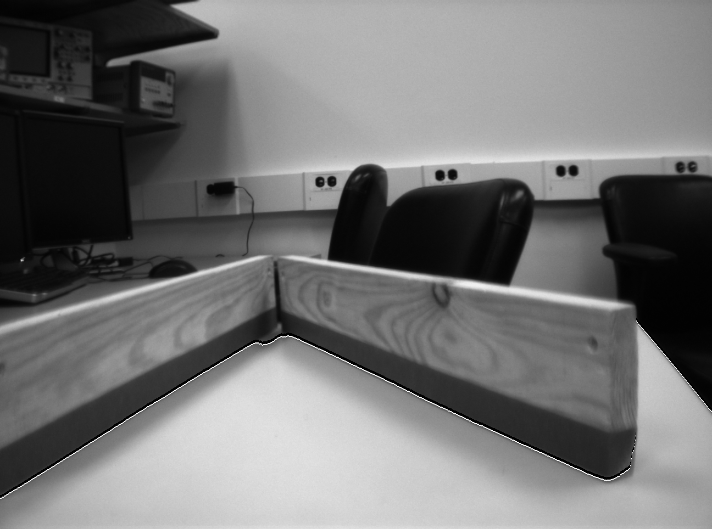

**Binary Thresholding**

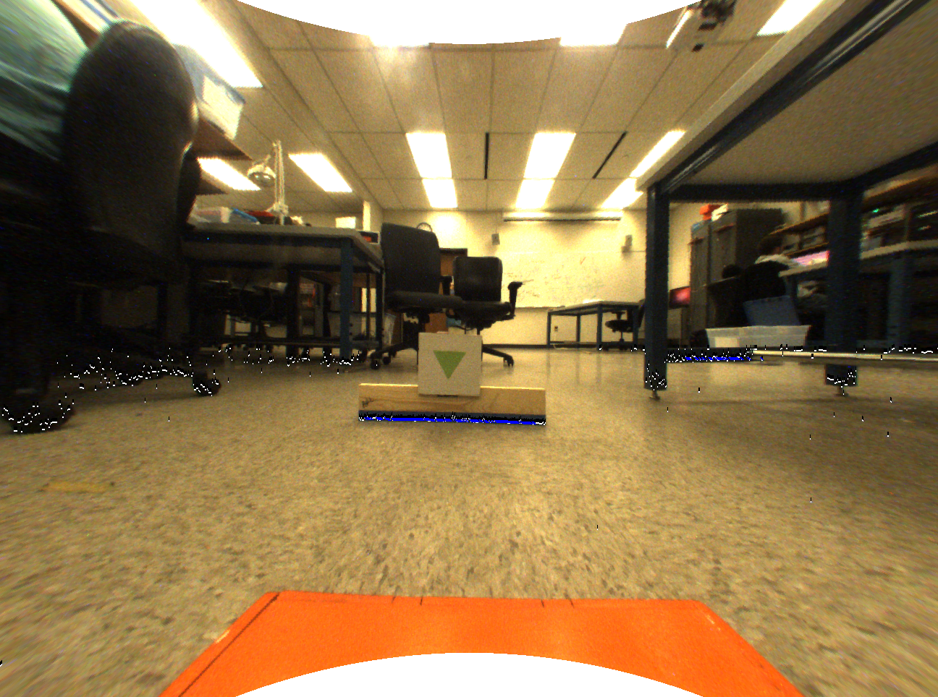

**Hue Thresholding with RANSAC**

|  |  |  |  |  |  |
| --- | --- | --- | --- | --- | --- |
| Image ID | Set | Initial Point | Final Point | Slope | Score |
| #1 | Test | (524, 581) | (739, 586) | 0.0233 | 0.996 |
|  | Ground | (495, 580) | (753, 586) | 0.0233 |  |
| #2 | Test | (569, 547) | (725, 550) | 0.0192 | 0.878 |
|  | Ground | (547, 547) | (727, 550) | 0.0167 |  |
| #4 | Test | (590, 597) | (755, 590) | 0.0496 | 0.837 |
|  | Ground | (583, 581) | (753, 587) | 0.0353 |  |
|  | Test | (1138, 672) | (915, 580) | 0.4125 | 0.969 |
|  | Ground | (1139, 673) | (891, 567) | 0.4274 |  |

**Ground Truth Evaluation on Final Blue Line Detection Algorithm**

*Q2.3.

Q2.4. Before computing any camera parameters, we had to fix radial distortion. In order to fix radial distortion, we took advantage of the idea that every pixel is a vector from the center of the image, with a distortion function:



Thus, we reduced the problem of radial distortion to solving for parameters A and B. We solved for these parameters to correct our radial distortion. These parameters are defined in the parameter table below. The intrinsic parameters (focal length and camera center) were solved for post-rectification by implementing a basic calibration technique. We set up point correspondences from pixels to real-world coordinates and solved an affine transform to get these parameters. These parameters are also defined in the parameter table below. The extrinsic parameters are the change in theta, and change in x from a previous position to a new location. The extrinsic matrix, then, is a chain of rotations and translations from the initial point of the bot to its current position.

|  |  |
| --- | --- |
| **Parameter** | **Value** |
| A | 1.527995 |
| B | -0.000910 |
| Focal length (f) | 640.1483 |
| Camera Center x (c_x) | 676.0408 |
| Camera Center y (c_y) | 480.3221 |

*Q2.5.

**Task #3:**

Q3.1. The initial plan for our green triangle detection was to implement a union find search for pixels of high green intensity. In order to accomplish this task, we had to traverse the image multiple times. The first traversal mapped pixels to parent nodes, creating trees of joined pixels above a certain green threshold. We then built a hash map of stats useful to detect a triangle. The second traversal found the root nodes and updated the stats in the hash map for all root nodes in the hash map. A covariance matrix was then built and we used the stats to determine the shape of a pixel blob. This worked fairly well, but was quite slow.

Thus, we modified this algorithm to make it more efficient. We built a Boolean image representation that denotes if a pixel at a given location passes the green threshold test. We would then explore the surrounding pixels at this location to search for more pixels consistent with the threshold. This allowed us to jump during traversal instead of iterating over every pixel. We could then retrieve these groups of denoted points and do statistical analysis to analyze the shape of the data.

This algorithm does pick up quite a bit of noise. We believe that the green color used to signify a triangle accounts for some of the error, as this particular shade of green is hard to identify. We also attribute some of this error to the lack of quality of the camera. Occasionally, the algorithm will detect a green blob and identify it wrongly as a triangle, but most of the time finds the correct triangle and is able to accurately locate the triangle’s center. Below are some screenshots of our method and a table showing our results against the ground truth data. Scores are derived by how closely we are able to pinpoint the center of a triangle.

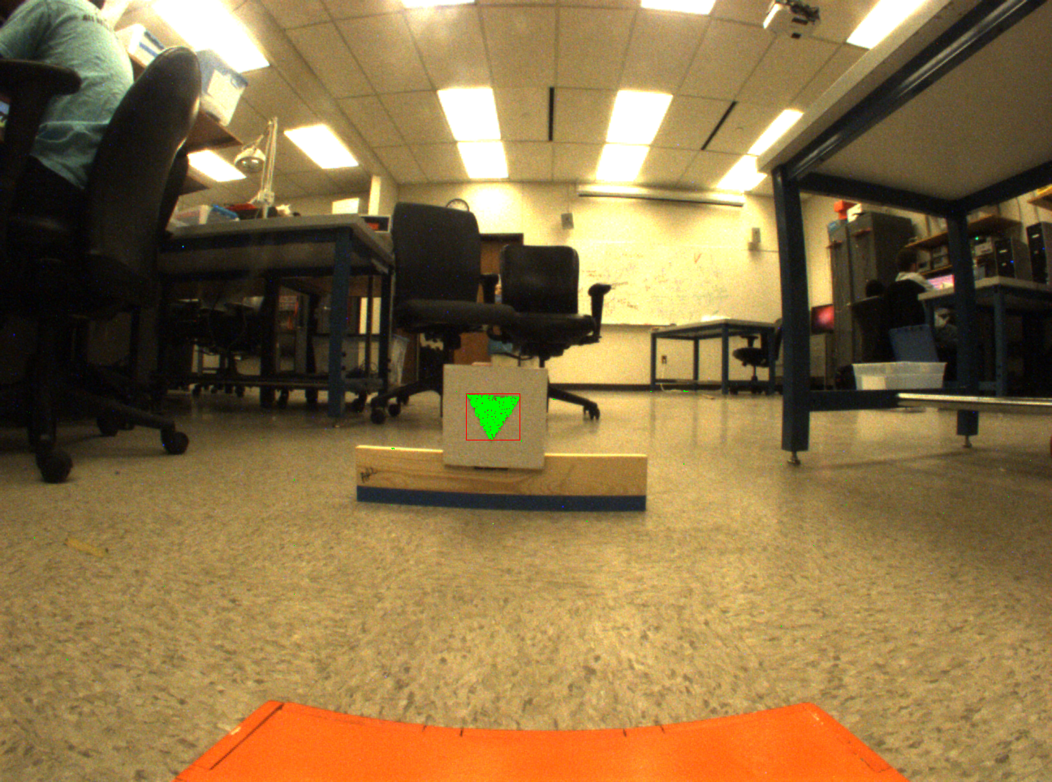 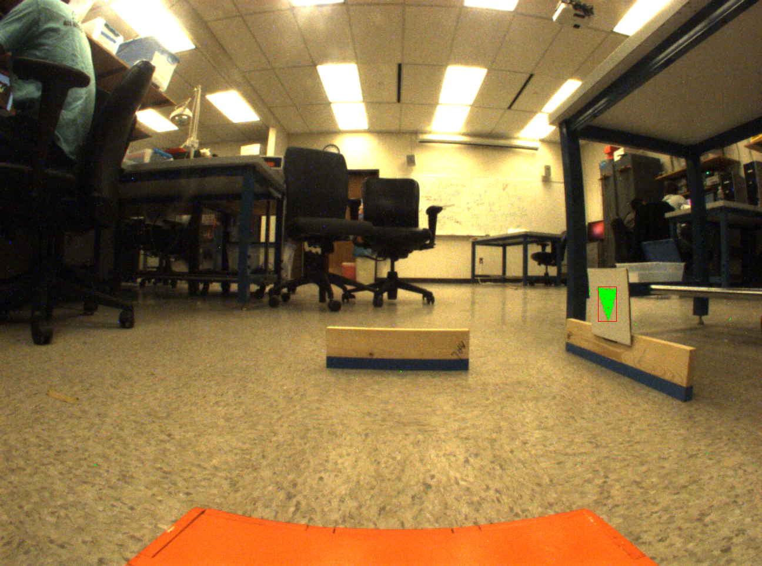

**Correct Identification Correct Identification**

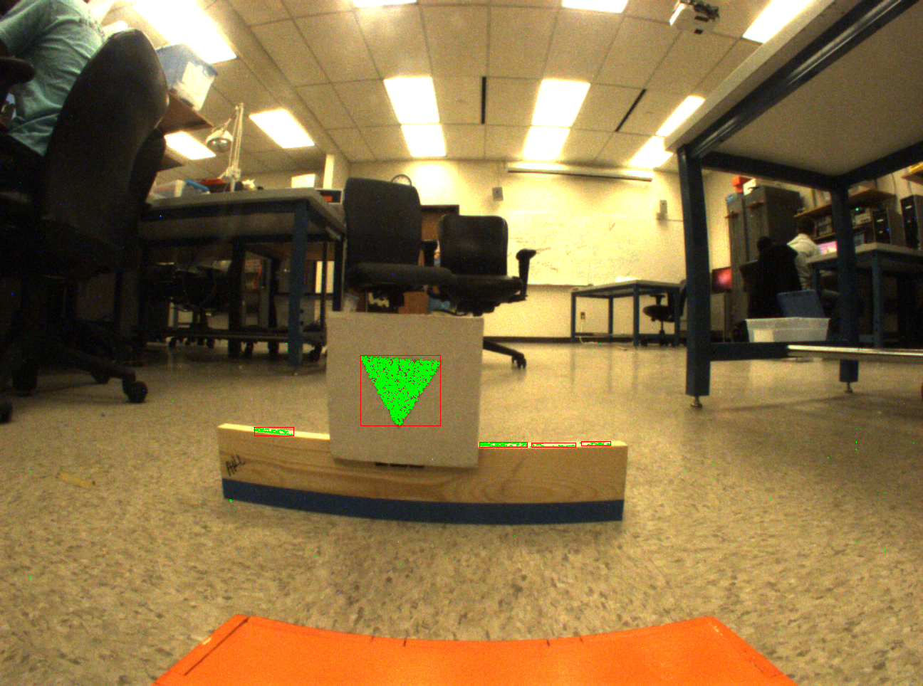 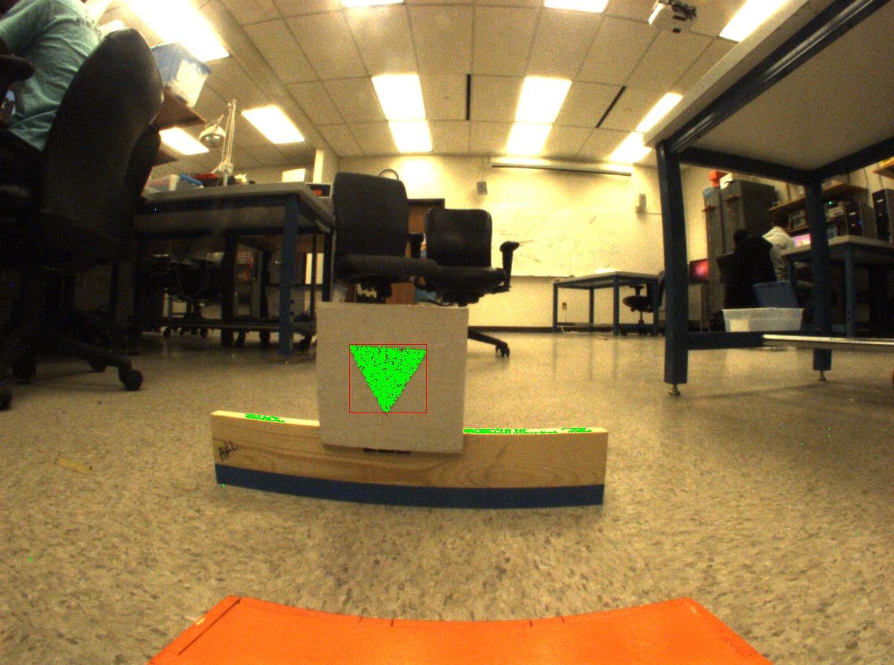

**Correct Identification With Noise Correct Identification Fixed Noise**

The last two pictures identify the main issue with this green triangle detection algorithm. It had picked up extraneous noise and detected it. In order to fix this noise, we implemented a simple thresholding technique that set a minimum for a number of pixels in a group if that group exceeded a maximum y coordinate threshold. The main cause of the extraneous noise is due to light reflected off of the wall. The light grows in intensity, as the wall gets closer to the camera. Objects also appear larger as they get closer to the camera. Thus, we are able to implement this constraint with a big enough count and maximum y coordinate threshold to make sure only triangles are found when a wall or triangle is close to a camera. Below is a table that evaluates the performance of this algorithm, comparing its results with ground truth data. The NULL in image 2 signifies that the triangle was never detected. This is because the triangle was too far away for the algorithm to find.

|  |  |  |  |
| --- | --- | --- | --- |
| Image ID | Test Center | Ground Center | Score |
| 1 | (607, 513) | (606, 512) | 0.9982 |
| 2 | NULL* | (626, 498) | NULL* |
| 3 | (562, 548) | (561, 547) | 0.9982 |
| 4 | (1032, 517) | (1032, 515) | 0.9997 |

*Q3.2.

**Task #4:**

*Q4.1.

*Q4.2.

*Q4.3.

*Q4.4.